VPC CHALLENGES
USE CASE: Setting up Transit Gateway and VPC Endpoints for a Multi-VPC Architecture
SCENARIO:
A large organization is migrating its on-premises infrastructure to the AWS cloud.
The organization's architecture involves multiple VPCs for different departments and applications, each requiring secure communication with centralized services and external resources.
The IT team needs to design and implement a scalable and efficient network architecture to accommodate the organization's growth and ensure robust connectivity between VPCs and external services.
Objectives:

Design and deploy a scalable network architecture using AWS Transit Gateway to simplify network connectivity between multiple VPCs.
- Create three vpc with one for public and two for the private
1) 172.168.0.0/24
Cidr range of 3 vpc’s created
2)10.0.1.0/28
3) 10.0.0.0/28
- Create the subnets to the vpc’s created
- Go to transit gate way create one transit gateway
- Then create transit gateway atachments to the vpc’s
- Then launch three instances with three vpc’s
- No connect to the vpc 1 with the public ip in CLI i.e git bash
- Then ping the private ip of the other two instances
- Attach the transit gateway to the public vpc of two other vpc cidr range created so that whwever try to connect to the vpc try to send to particular transit gateway.
- Do the same to the other vpc attach the vpc cidr range of other vpc –target transit gateway
- Create IGW (internet gate way and for vpc and attach to the routes
- If it not connecting go to ec2 – security group – add port no all traffic –then you can see coneection is established to private ec 2 created in CLI
- Use: ping <ip address private>

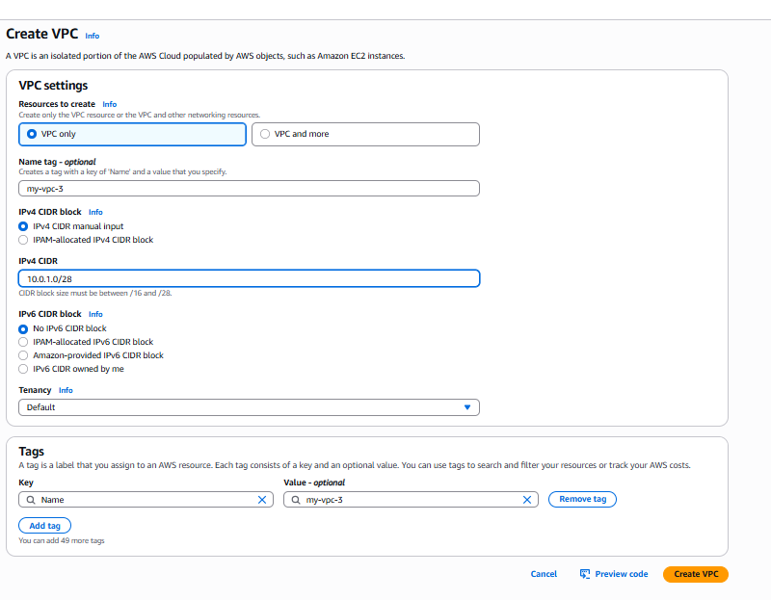
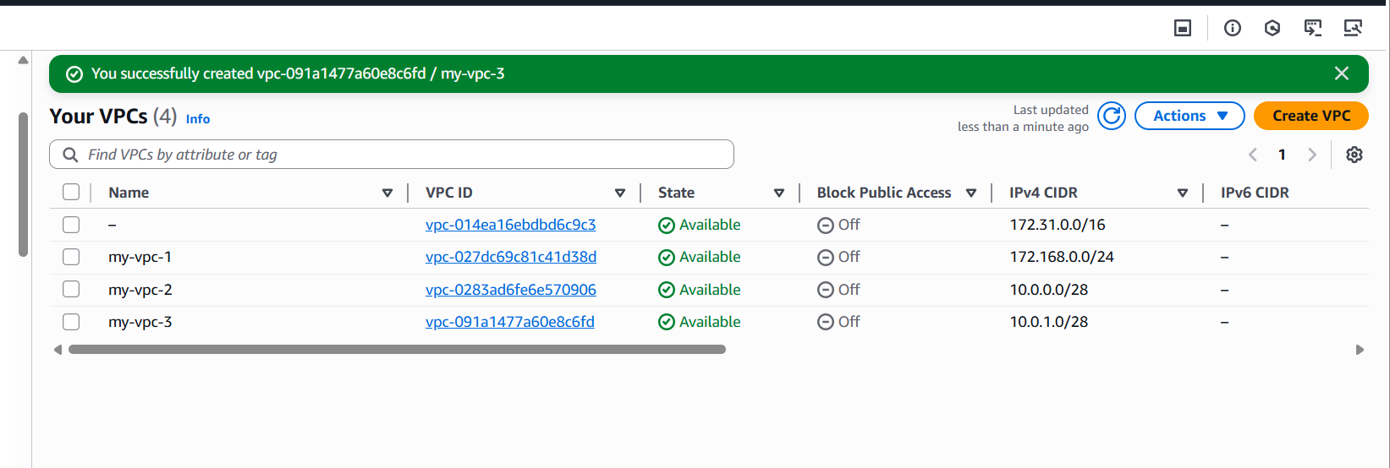
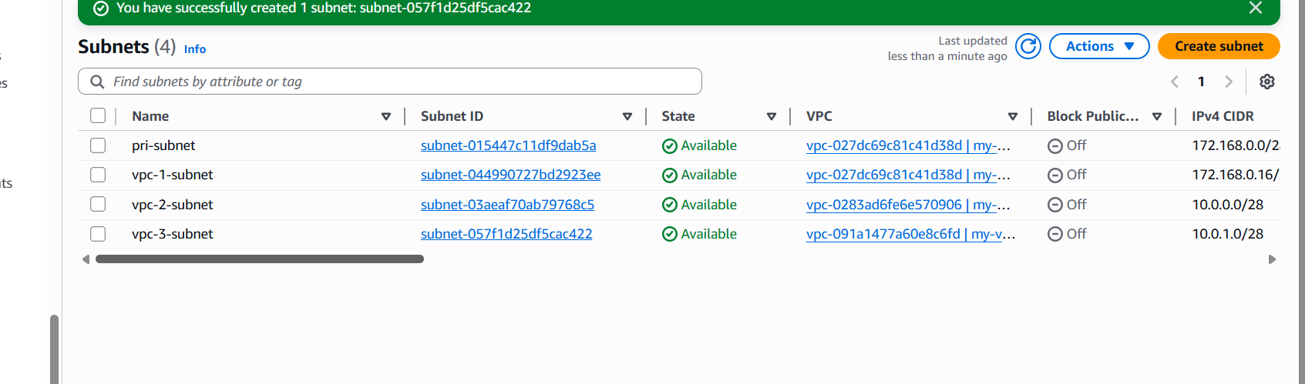
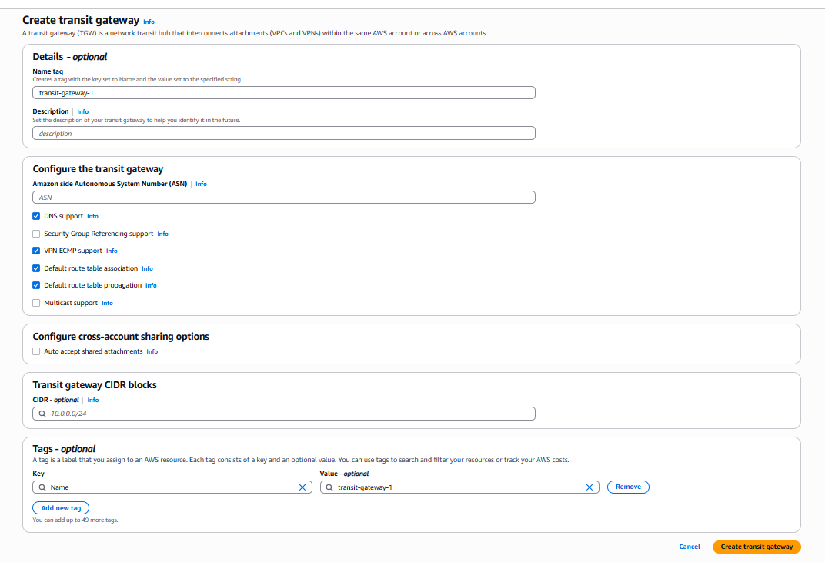
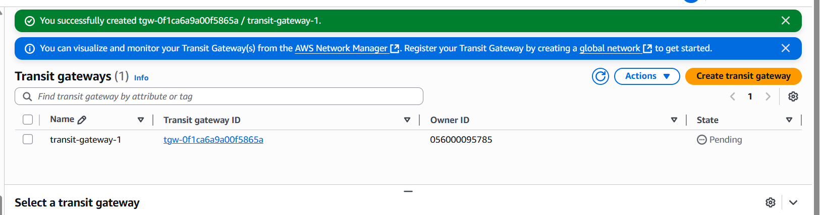
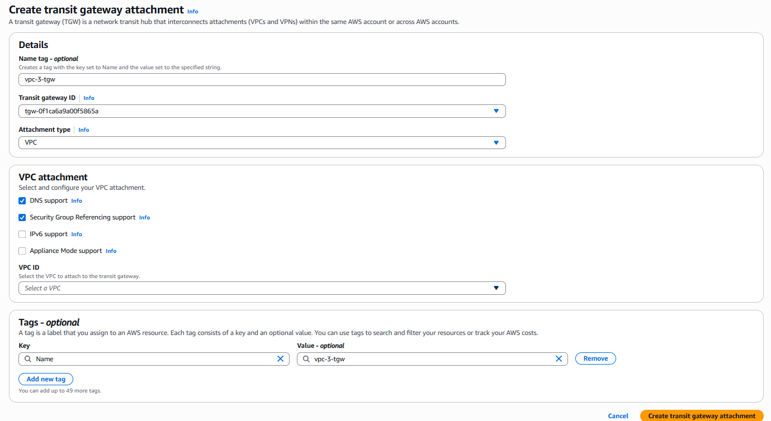
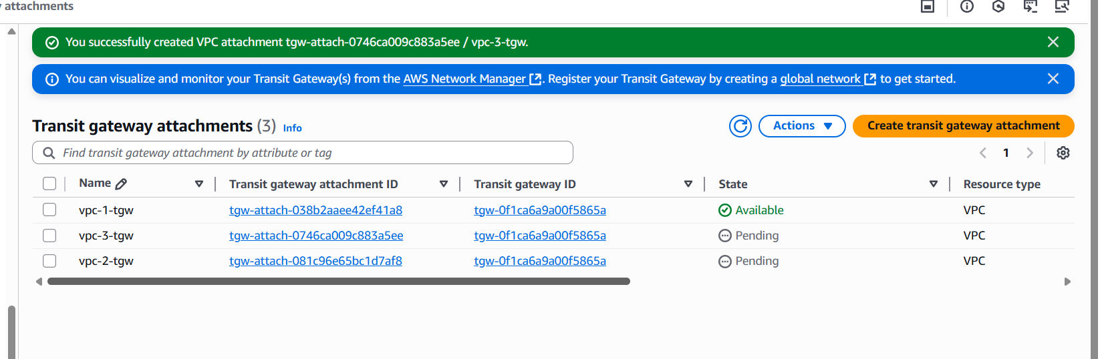
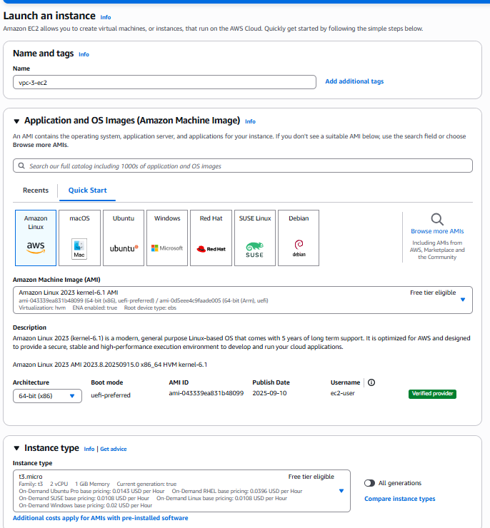
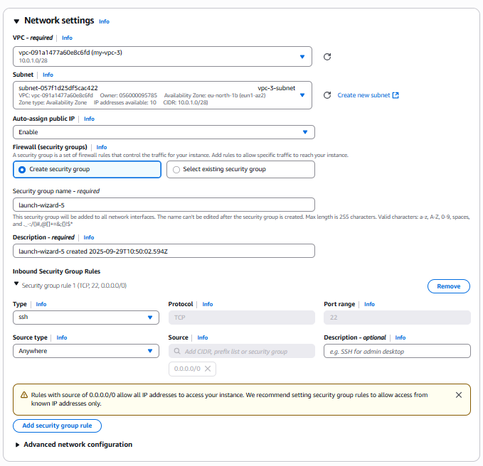
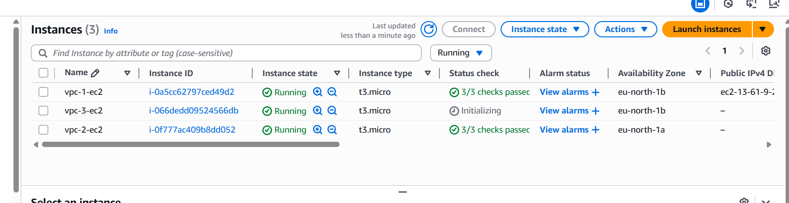
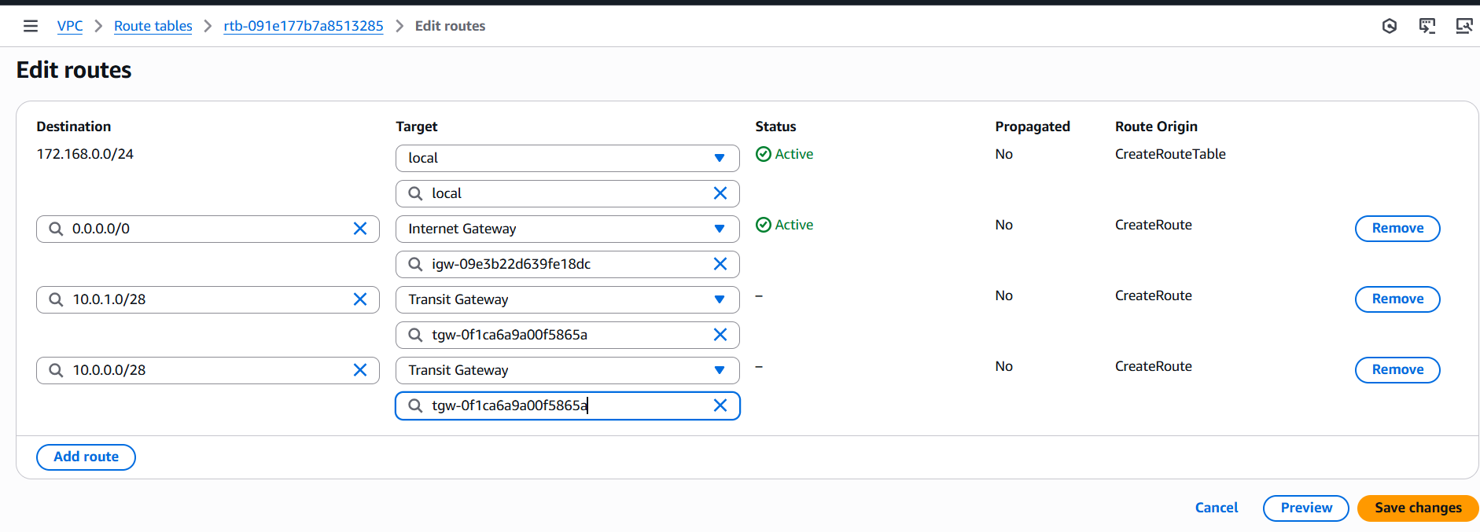
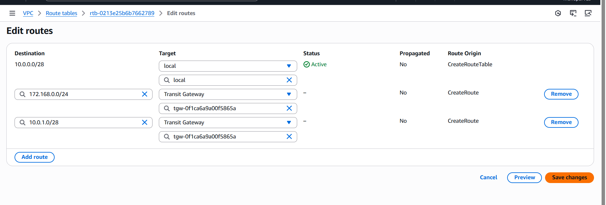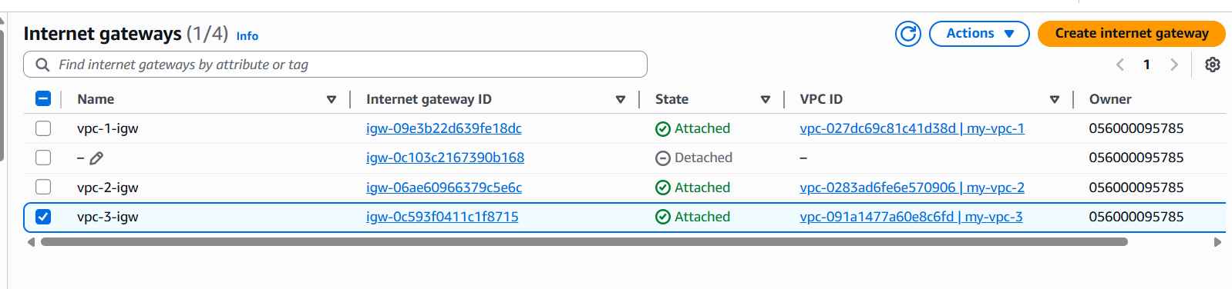
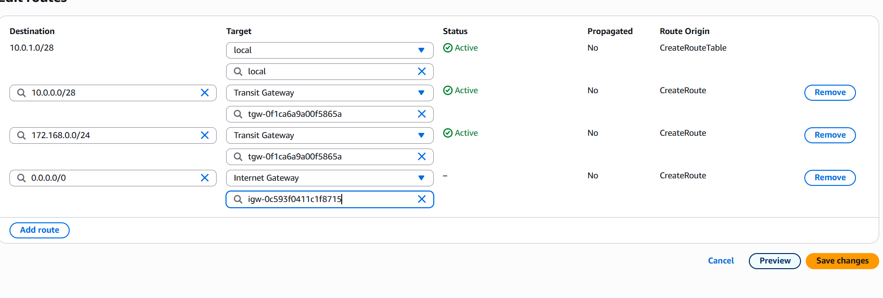
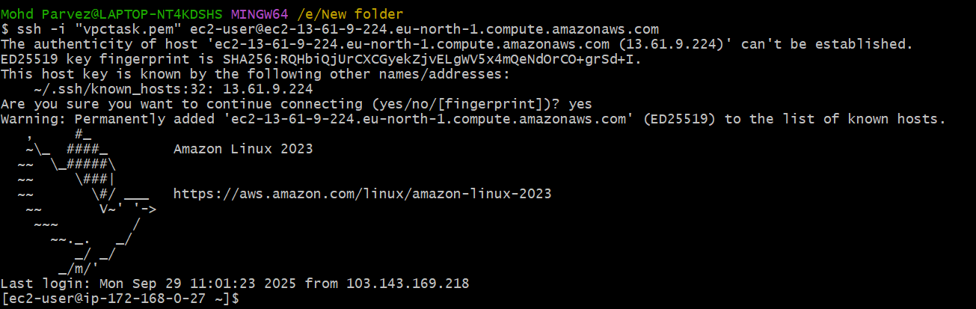
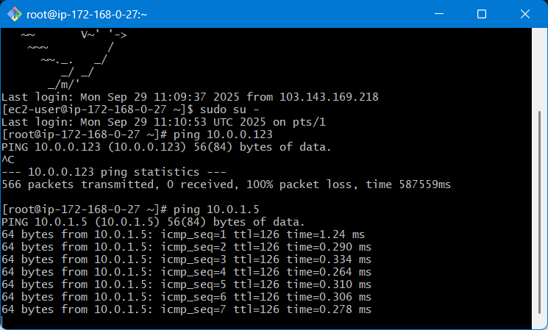
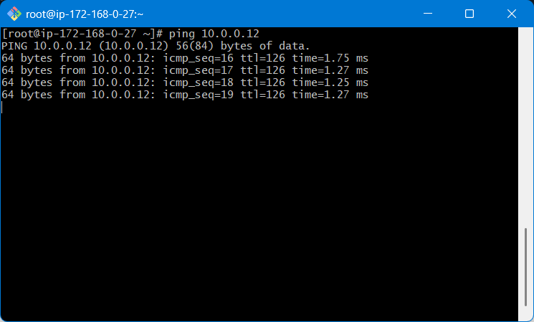
The transit gate way for the 3 vpc has benn done.

Configure VPC endpoints to securely access AWS services without internet gateways or NAT gateways, ensuring data privacy and minimizing exposure to external threats.

- Lauch one public and private ec2 instance using private subnet and public subnet
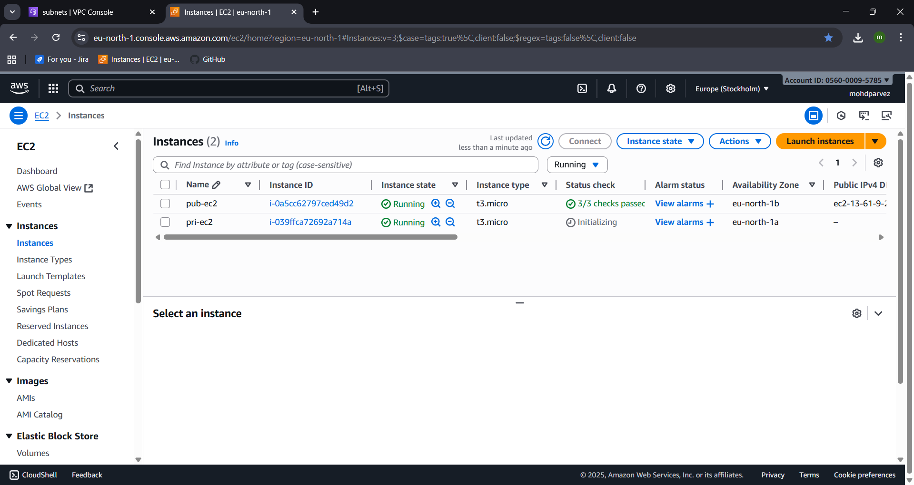
- Create one s3 bucket
- Go to s3 service
- Create s3 bucket the name of the bucket should be unique

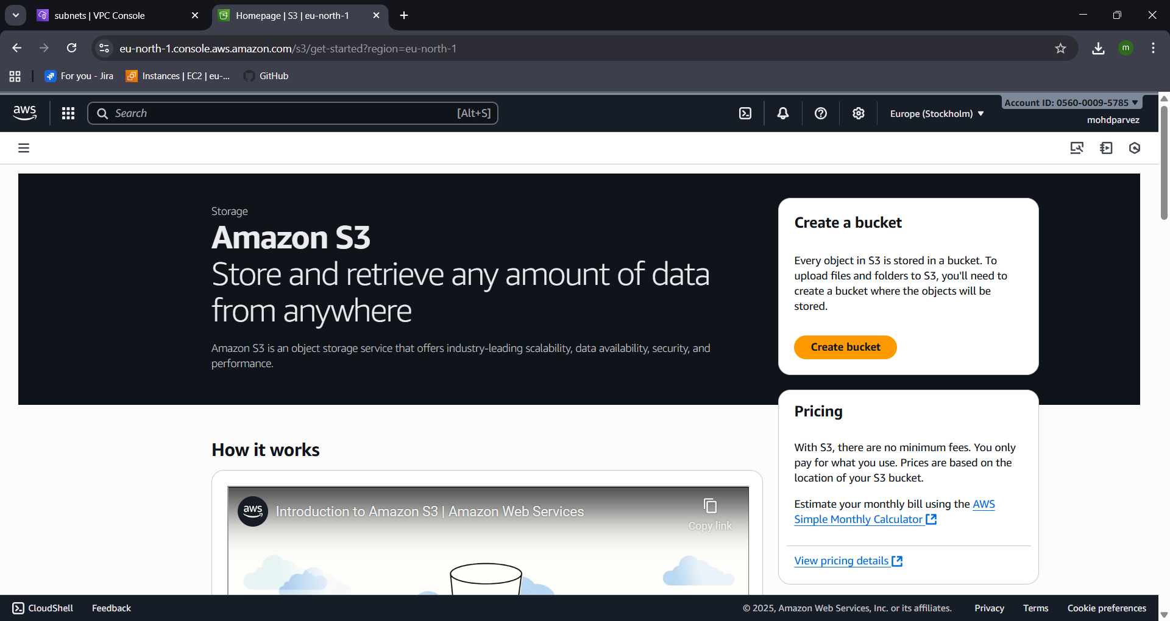
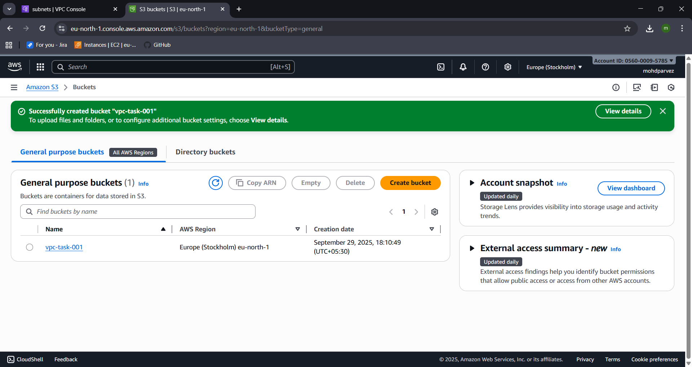
- Now connect to public ec2
- Use git bash
- Use ssh command to connect
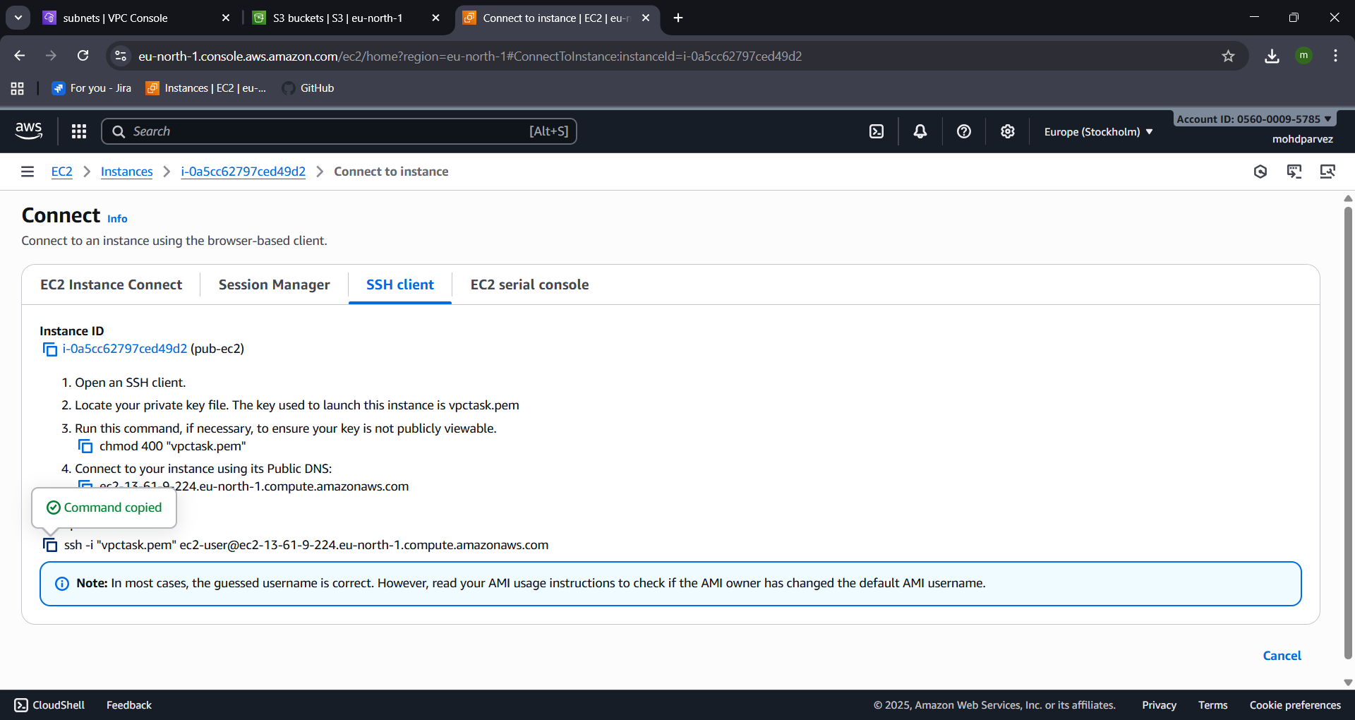

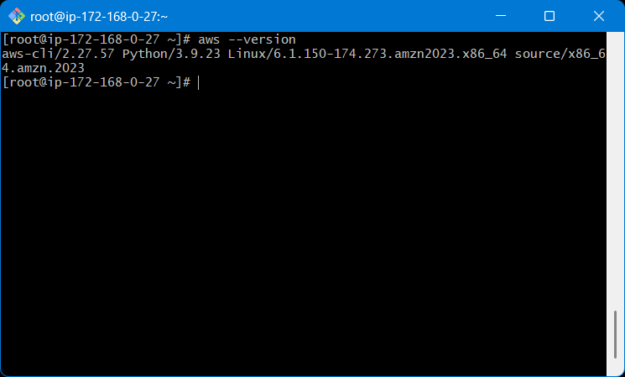
- Use aws configure : programmatic acess
- Provide acess key and secret key to configure
- Don’t have that then create in security crenditials by searching it then find create key there you can create the key
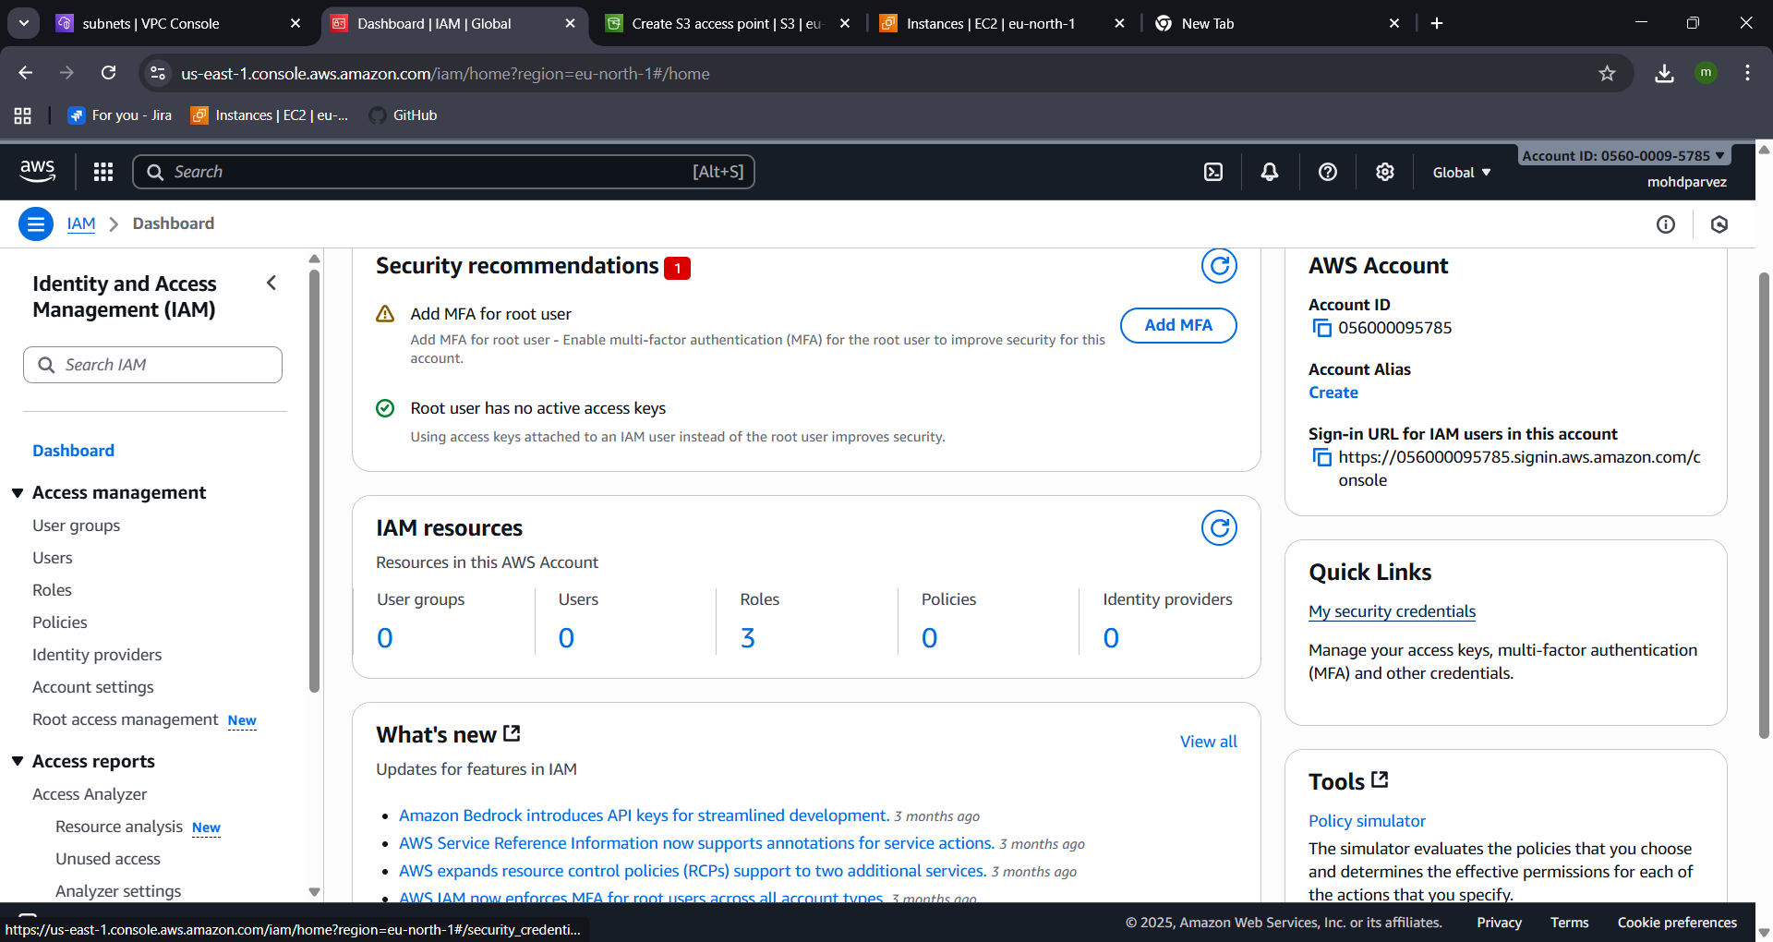
- Provide the details select the output format and region
- Use : aws s3 ls , you can see that you can acess the s3 bucket in cli
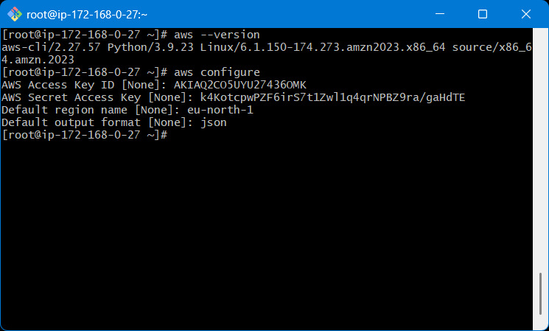
- Copy the pem key from local use cat to see the key
- Then create the pem key file and give permission: chmod 400 filename.pem
- Then use : ssh -i test.pem ec2-user@<privateip
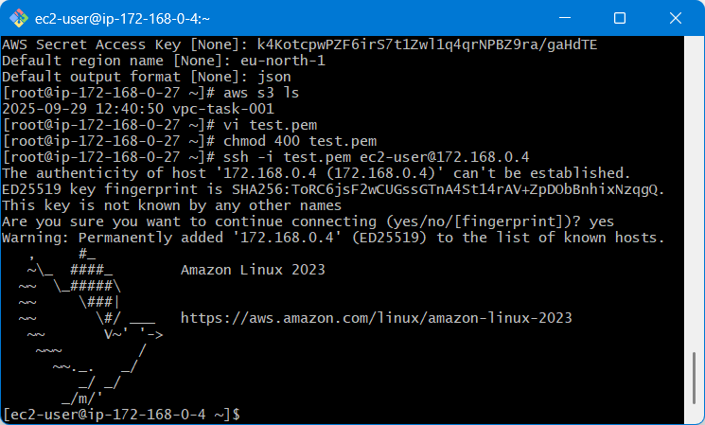
- After connecting to the private ec2
- Use aws configure and configure access key and secret key
- Select output format and region
- Now go to vpc
- Navigate to end points
- Select aws service
- Then select s3 and end point type expres
- Then select gateway
- Create end point the end point has been created
- Now you can acess the s3 from the private instance : aws s3 ls
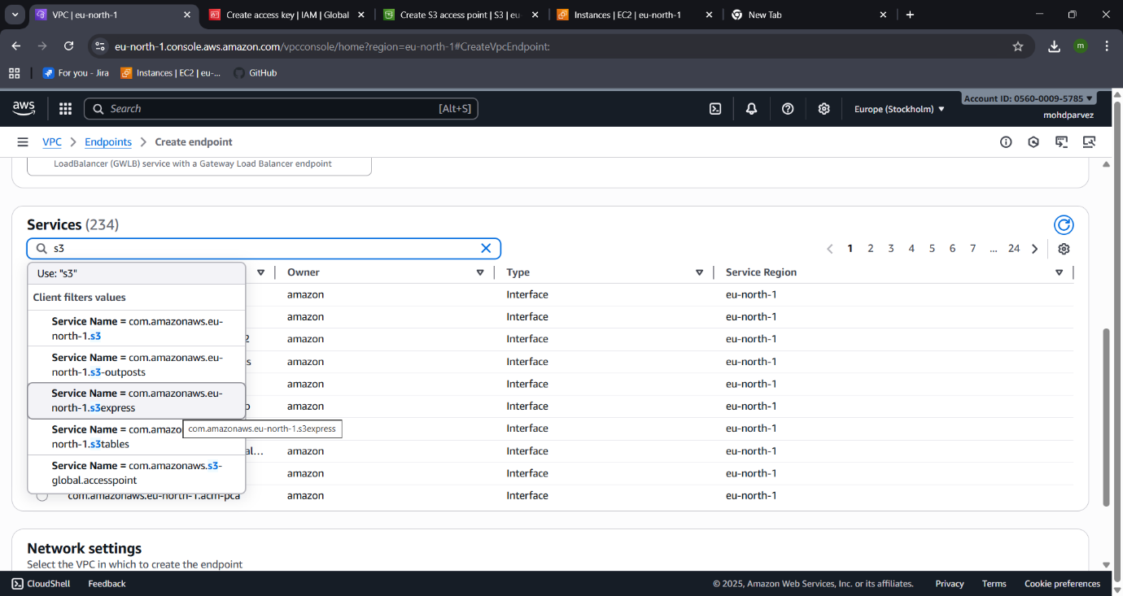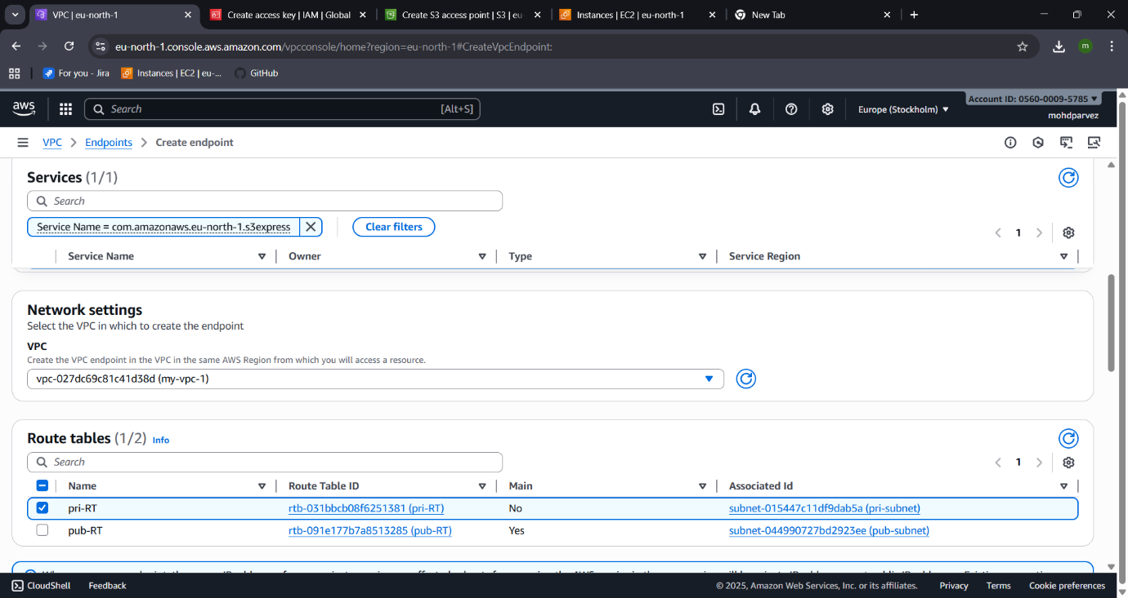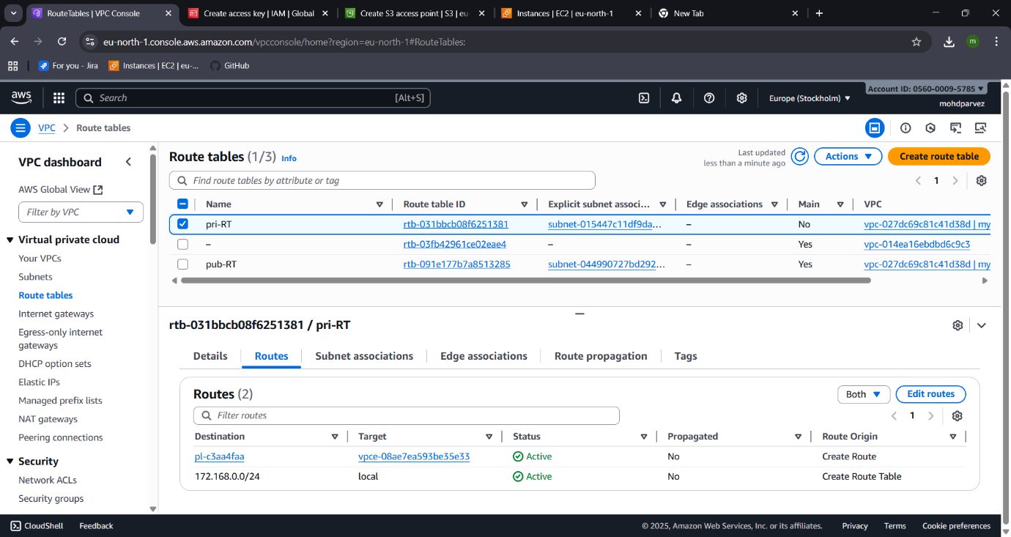
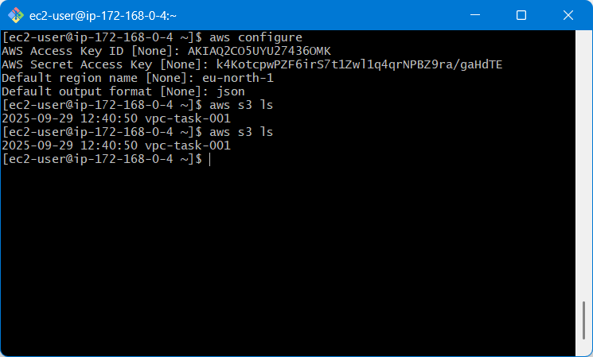
- You can see the s3 is a end point is set

